

**MARMARA UNIVERSITY**

**FACULTY OF ENGINEERING**

EE2004

Microprocessor Systems

**PROJECT I**

**Usage of Light Sensor with PWM and 7-Segment Display**

----------------------------------------------------------

**Name:** TUGRAHAN

**Surname:** KARAKADIOGLU

**Number:** 150720034

**Submitted to:** Prof. Dr. Cem ÜNSALAN

**Due Date:** 15.06.2022

***Usage of Light Sensor with PWM and 7-Segment Display***

**Introduction**

Light Dependent Resistance is a type of sensor that changes with the light intensity falls upon it. This is useful for light sensing circuits.

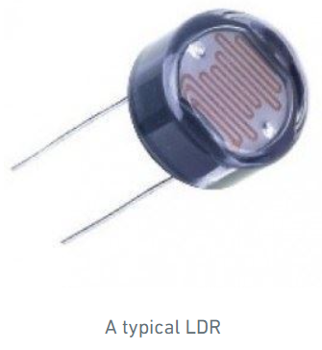

*Figure -1) A typical LDR*

Application of LDR:

Switch Lighting

The application for an LDR is to automatically turn on a light at a distinct light level. Street light can be a example of this usage.

PWM(Pulse Width Modulation) is one of the important functions of timer. PWM has a purpose to control analog circuits with digital output from microcontroller or microprocessors.

PWM consist of two components:

Duty cycle describes the amount of time, the signal is in logic 1 state as a percentage of total time, it takes to complete one cycle.

Frequency describes how fast the PWM completes a cycle and therefore how fast it changes between logic 1 and logic 0.

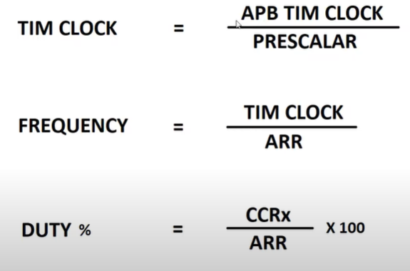For our microprocessor, the formulas for PWM is in below.

*Figure -2) Formulas for PWM*

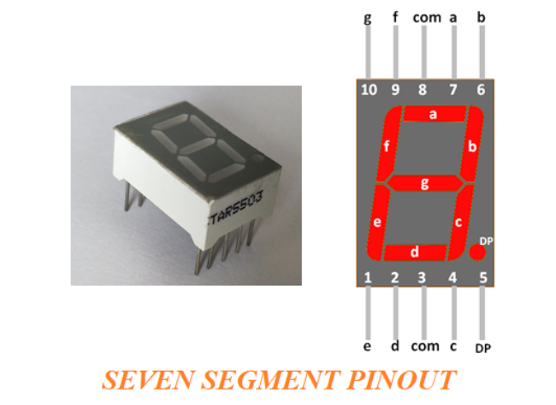

*Figure -3) 7-Segment*

The 7-Segment display units are some LED bars together as shown in this picture above. Two types are available to use one is common anode and the other is common cathode). The one shown above is a common anode 7-Segment display unit. You need to give LEDs logic 0 in order to turn it one while the common pin is hooked to the Vcc.

**REQUIRED COMPONENTS**

-Breadboard

-Nucleo L073RZ

-Resistors(10k)

-Jumper wires

-USB Cable

-Seven Segment Display(5161BS-Common anode)

-LED (Red)

-LDR(Light Dependent Resistor)

**CIRCUIT DESCRIPTION**

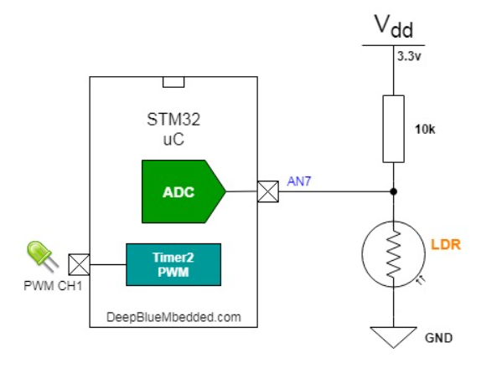

*Figure -4) Circuit Schematic*

metin, elektronik eşyalar içeren bir resim

Açıklama otomatik olarak oluşturulduHere I have a LDR and resistor connecting serial. I use 3.3V as DC Power Supply. Between LDR and resistor, there is a analog pin to get the value from sensor.

**STM32CubeIde Part**

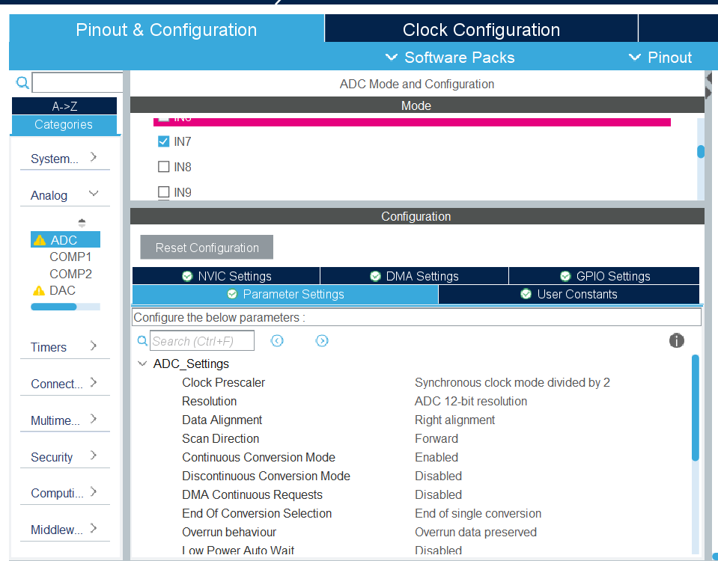

*Figure -5) ADC part*

I used the Analog pin 7 to get the value from sensor. I enabled continuos conversion mode to get value continuosly.

metin içeren bir resim

Açıklama otomatik olarak oluşturuldu

*Figure -6) Timer part*

I used TIM2 to generate pwm outputs. So, I enabled PWM Generation CH1. The pin for this purpose is PA_0. Also, I enabled auto-reload part.

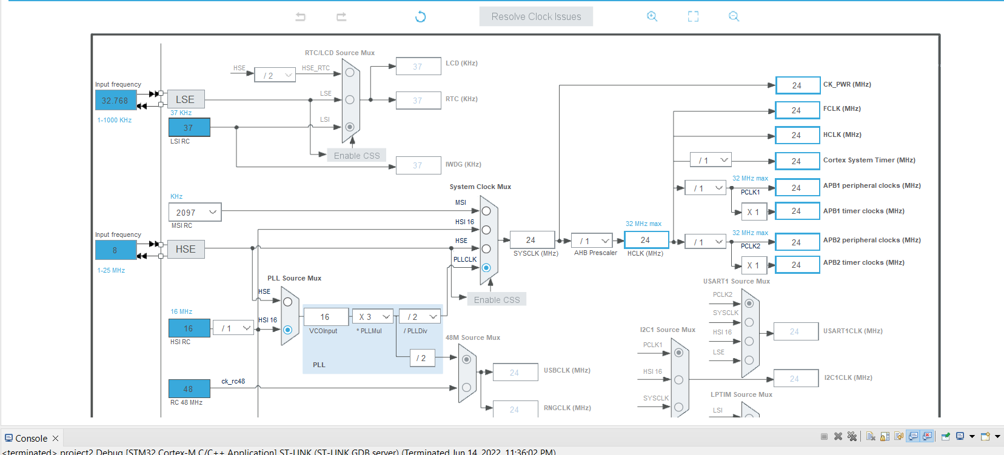

*Figure -7) Clock part*

metin içeren bir resim

Açıklama otomatik olarak oluşturulduMy PLLCLK is 24MHz and APB2 timer clock is 24MHz. So, from figure -6 my prescaler value is 24 and counter value is 100. Thus, I have a 10kHz frequency.

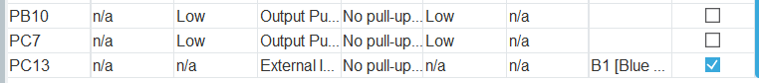tablo içeren bir resim

Açıklama otomatik olarak oluşturuldu*Figure -8) Debug serial wire*

*Figure -9) 7-Segment GPIO Arrangements*

We have 7 leds to generate 7-Segment display. So, I attached 7 pins as GPIO_Output. I plug 3.3V to common part.

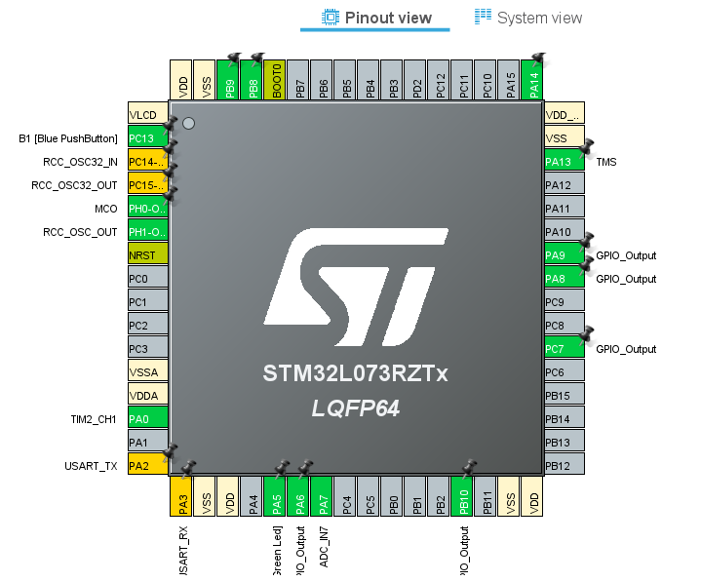

*Figure -10) Pinout View*

**CODE IMPLEMENTATION**

metin içeren bir resim

Açıklama otomatik olarak oluşturuldu

Here, I started the timer2 in the first line and I started the initialization of PWM generation in second line.

metin içeren bir resim

Açıklama otomatik olarak oluşturuldu

In while loop, in the first line I started the ADC. In the second line I ordered the ADC module to convert values between 1 seconds. With the help of GetValue function I got the value from the ADC.

metin, elektronik eşyalar, klavye içeren bir resim

Açıklama otomatik olarak oluşturuldu

*Figure -11) 7-Segment Truth table*

Before going further, we should analyze this table for 7-segment display. For example to generate 1 we should enable pin b and pin c.

But I should note here. Because we used common anode we should give logic 0 to pins.

metin içeren bir resim

Açıklama otomatik olarak oluşturuldu

As an example, I assigned some levels to readValue. For example if it is larger than 150 it should generate number 9. So, I should close to PB_10.

Below that line, this line contributes to PWM pulsewidth. So, I assigned 120 for LED to be more bright. With the help of HAL_TIM_PWM_Start. The other levels are same as this example.



With this function, I delay the function by 50ms. So that I can get quick results.

**CONCLUSION**

The results are good so that my project works fine. I can change the levels of ADC value to get more precise values.

This project helped me to understand PWM and ADC usage.

Also, I used 7-segment display first in here. I understood the pin parts and difference between common anode and common catode.

REFERENCES

- <https://controllerstech.com/pwm-in-stm32/>

- https://www.youtube.com/watch?v=OwlfFp8fPN0

- <https://deepbluembedded.com/interfacing-7-segment-display-stm32/>

- <https://kitronik.co.uk/blogs/resources/how-an-ldr-light-dependent-resistor-works>

- <https://www.geeksforgeeks.org/bcd-to-7-segment-decoder/>

- <https://circuitdigest.com/microcontroller-projects/arduino-hall-effect-sensor>